Append notes instead of replacing notes in Time of Event and Work Time Event:

Before:

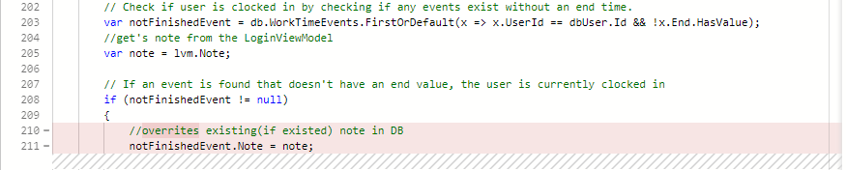

After:

